Ccure 9000: How to View or Delete your Manual Actions

- In Ccure Monitoring Station, select “Manual Actions” in the right-side Explorer Bar.
- Find the manual action on via the filter button in the top tool bar or by scrolling through the list.
- Once action is located select the action by clicking once on the row (will turn blue), then right click.
- From the menu, choose “details” or “cancel.”
- For viewing/details of a manual Action a box will pop up:
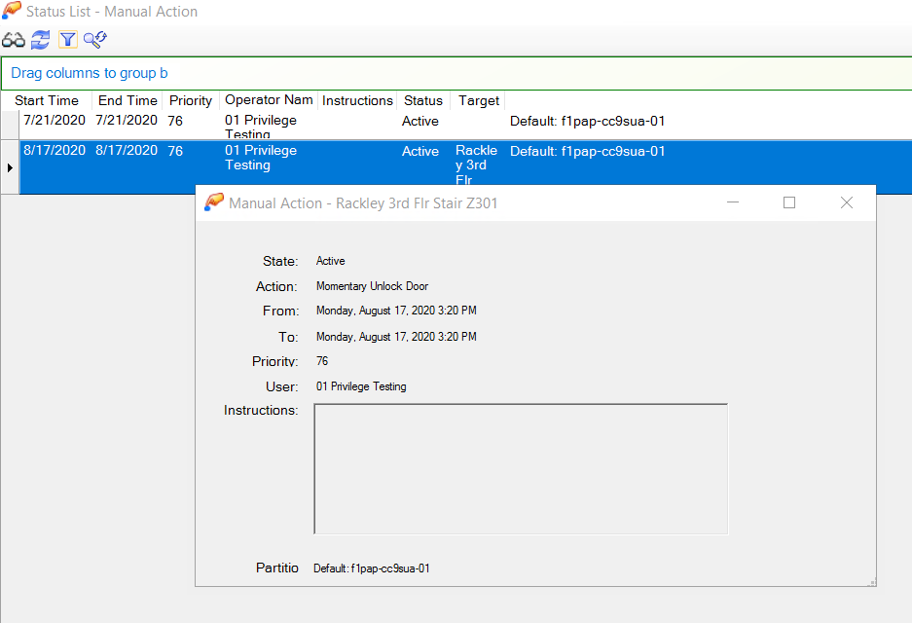

- If canceling a Manual Action, the action will disappear from the main list. Your action is canceled.

