Ccure 9000: How to Review a Clearance

- In Ccure Monitoring Station select “Dynamic View” in the right-side Explorer Bar.
- A dialogue box will appear, select “Clearance View” by double clicking.
- Click “Run”
- Find the clearance to review via the filter button in the top tool bar or by scrolling through the list.

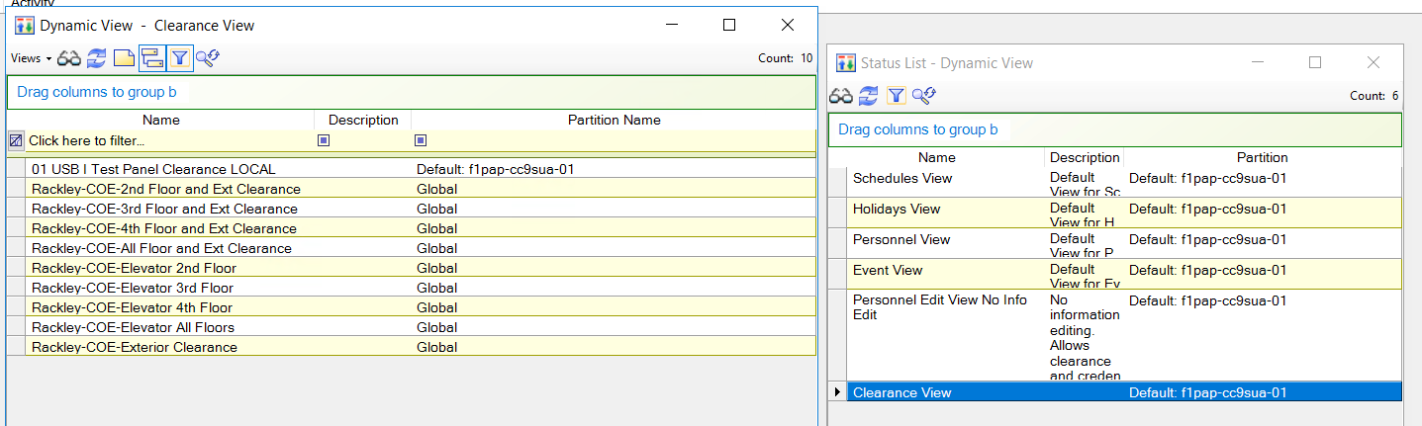

- Double click on the clearance you want to review, and the clearance will open.
- On the General tab if the “Active On” and “Expire On” dates are checked, the clearance will only be active during the specified timeframe. If they are blank, the clearance will be active indefinitely.

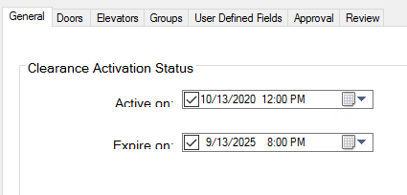

- On the Doors tab you can review the doors/door groups and schedules that are associated with the doors/door groups on the clearance. You are not able to edit the doors or schedule and requests for edits should be submitted to the Physical Security Office.
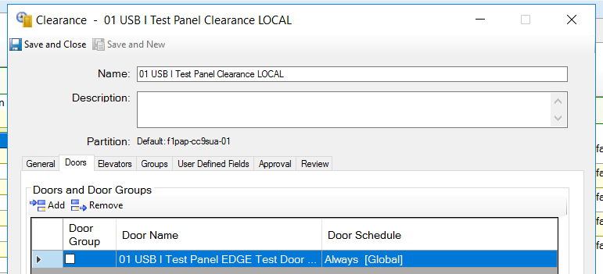

To review who has access to a clearance, take the following steps:

- Follow steps 1-4 above.
- Right click on the clearance and select “Show Associations.”
- The dialogue box that will appear will show you any objects or people associated with the clearance. To review the people associated with the clearance, double click Personnel.

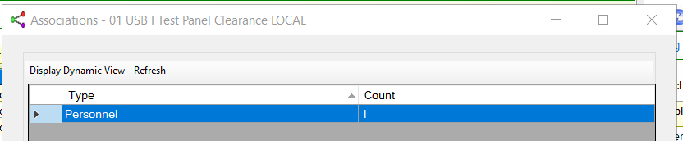

- The list that displays are the personnel who are assigned the selected clearance.
- You can then audit those on the clearance list.
- To remove the clearance follow the guide for “How to Add/Remove a Clearnce to Personnel” or you can also do this in bulk by selecting multiple perrsonnel on the list (using the Shift or Ctrl keys), right click and select remove clearnce. You will need to select the clearance to remove from the displaying box.
- Click OK.
- The selected clearnce will now be removed from the selected indviduals.

