Ccure 9000: How to Review/Edit a Door Schedule

- In Ccure Monitoring Station select “Dynamic View” in the right-side Explorer Bar.
- A dialogue box will appear, select “Schedule View” by double clicking.
- Find the schedule to review/edit via the filter button in the top tool bar or by scrolling through the list.
- Double click on the schedule you want to review/edit and the schedule will open.
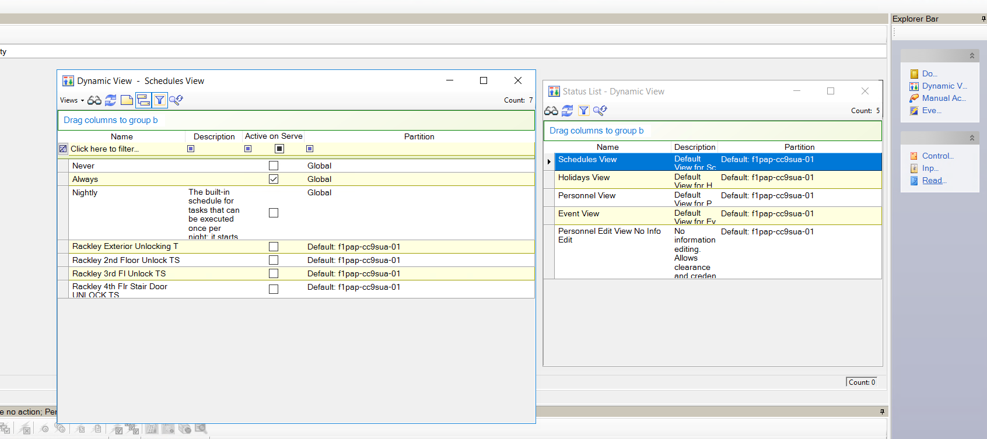
- The first section, “Activate During Specified Intervals”, is where you will enter your door unlocking schedules. You will use each line for a time schedule. In the example below, the doors will be unlocked Monday-Friday 8:30AM-5PM. You will edit the start and end time and select the days by clicking on the buttons below the day you need that schedule to activate. For different times on different days, select “Add” to add a different time schedule.
*When typing in the time, make sure you click on an area outside of the time box before clicking on “Save and Close”, or your time will not change.

- Once you are done adding the day/time schedules, click “Save and Close.”
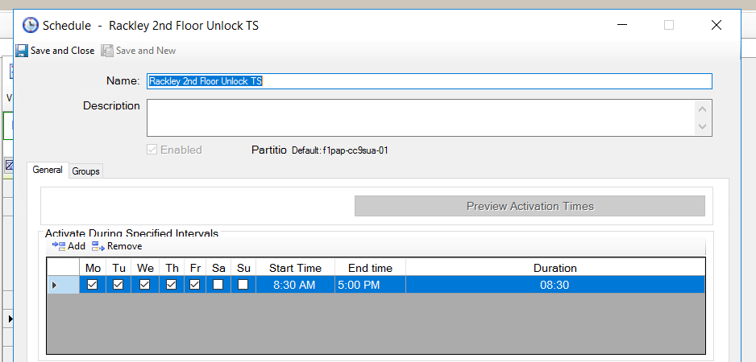
- Note – if you are unsure of the time schedule for your event, you can resource the associated time schedule by looking at the event and noting the schedule name in the “Activate on Schedule” line.

