Ccure 9000: How to Look Up Doors

- In Ccure Monitoring Station select “Doors” in the right-side Explorer Bar.
- Find the door to perform Lock/Unlock function on via the filter button in the top tool bar or by scrolling through the list.

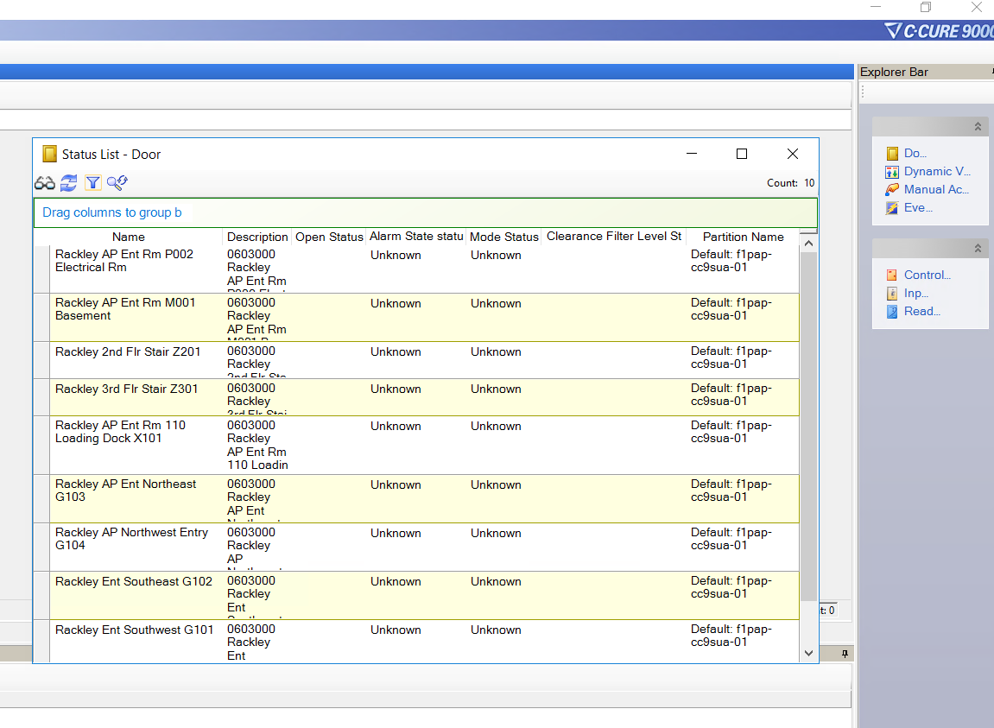
- The top headers will provide you with information regarding the doors such as; Open Status (open vs. closed), Alarm Status (held vs. forced vs. normal), Mode Status (locked vs. unlocked).

