Ccure 9000: How to Add/Remove a Clearance to Personnel

- In Ccure Monitoring Station select “Dynamic View” in the right-side Explorer Bar.
- A dialogue box will appear, select “Personnel by” Name, PSU ID, or User ID by double clicking.
- Search for the individual using the method you selected.
- Find the person to review via filter button in the top tool bar or by scrolling through the list.
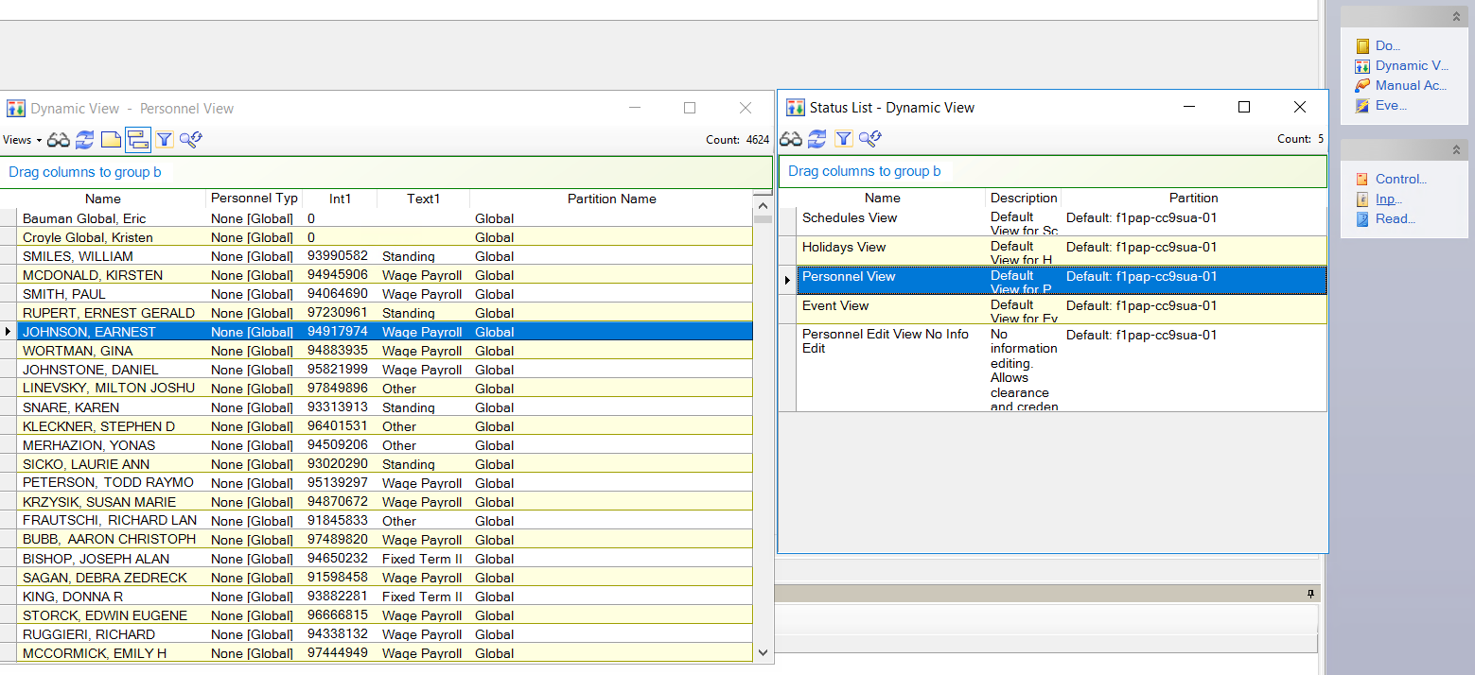

- Double click on the person you want to add a clearance to, and the record will open.
- On the personnel record select the “Clearance” tab.
- Click Add in the Clearance section. A clearance dialog box will appear.
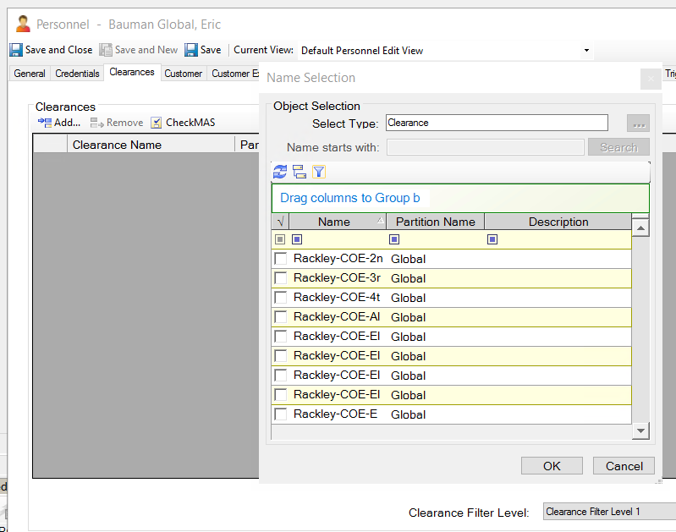

- Find the clearance to add via filter button in the top tool bar or by scrolling through the list.
- Place a check mark next to the clearance(s) that you want to assign, click OK.
- The clearance will populate on the record. To save the assignment of the clearance, click Save and Close.

To Remove a Clearance:

      - To Remove a clearance, perform steps 1-5.
      - On the personnel record select the “Clearance” tab.
      - Select the clearance you want to remove by left clicking on the clearance name turning the line blue.
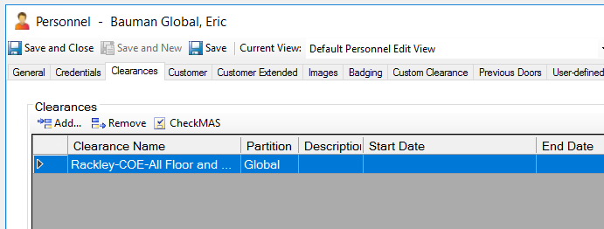

      - Click Remove.
      - A dialog box will appear confirming that you want to delete the clearance from the personnel record. Click Yes.
      - The clearance will be removed from the record. To save the removal of the clearance, click Save and Close.

To Add/Remove a Custom Clearance: (Custom Clearances should only be used for a 30 day time period or less)

- To add a Custom Clearance, perform steps 1-5 above and then click on the Custom Clearance tab.
- On the personnel record select the “Custom Clearance” tab.
- Click Add in the Custom Clearance section. A new Custom Clearance line will appear.
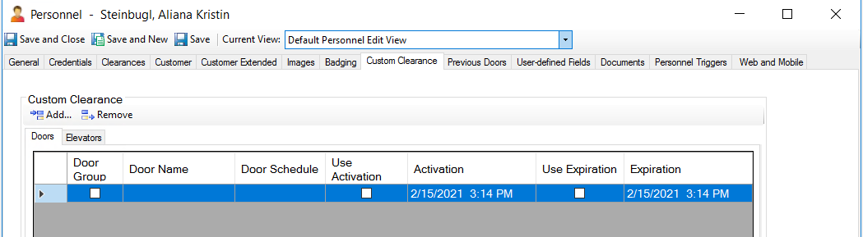

- To add the Door or Door Group click in the Door Name box and select the … button. (click “No” on thte Warning that appears).
- Find the clearance to add via filter button in the top tool bar or by scrolling through the list. To display Door Groups click the group button .
- Click on the desired Door or Door group to add.
- The Door/Door Group will populate on the record.
- Next select the Door Schedule by clicking in the Door Schedule box and select the … button.
- Click on the desired Schedule to add.
- The Schedule will populate on the record.
- In the Use Activation and Use Expiration column place a check mark in the empty boxes.
      - Next set the Activation and Deactivation dates and times in the respective boxes. To save the addition of the Custom Clearance, click Save and Close.
- You can add multiple lines for a variety of Doors of Door Groups.
- To delete an entry, click the Add button. The Delete button will then become available to then highlight the line(s) to delete and click on the Delete button (you must delete the blank line that is inserted). To save the removal of the Custom Clearance, click Save and Close.

